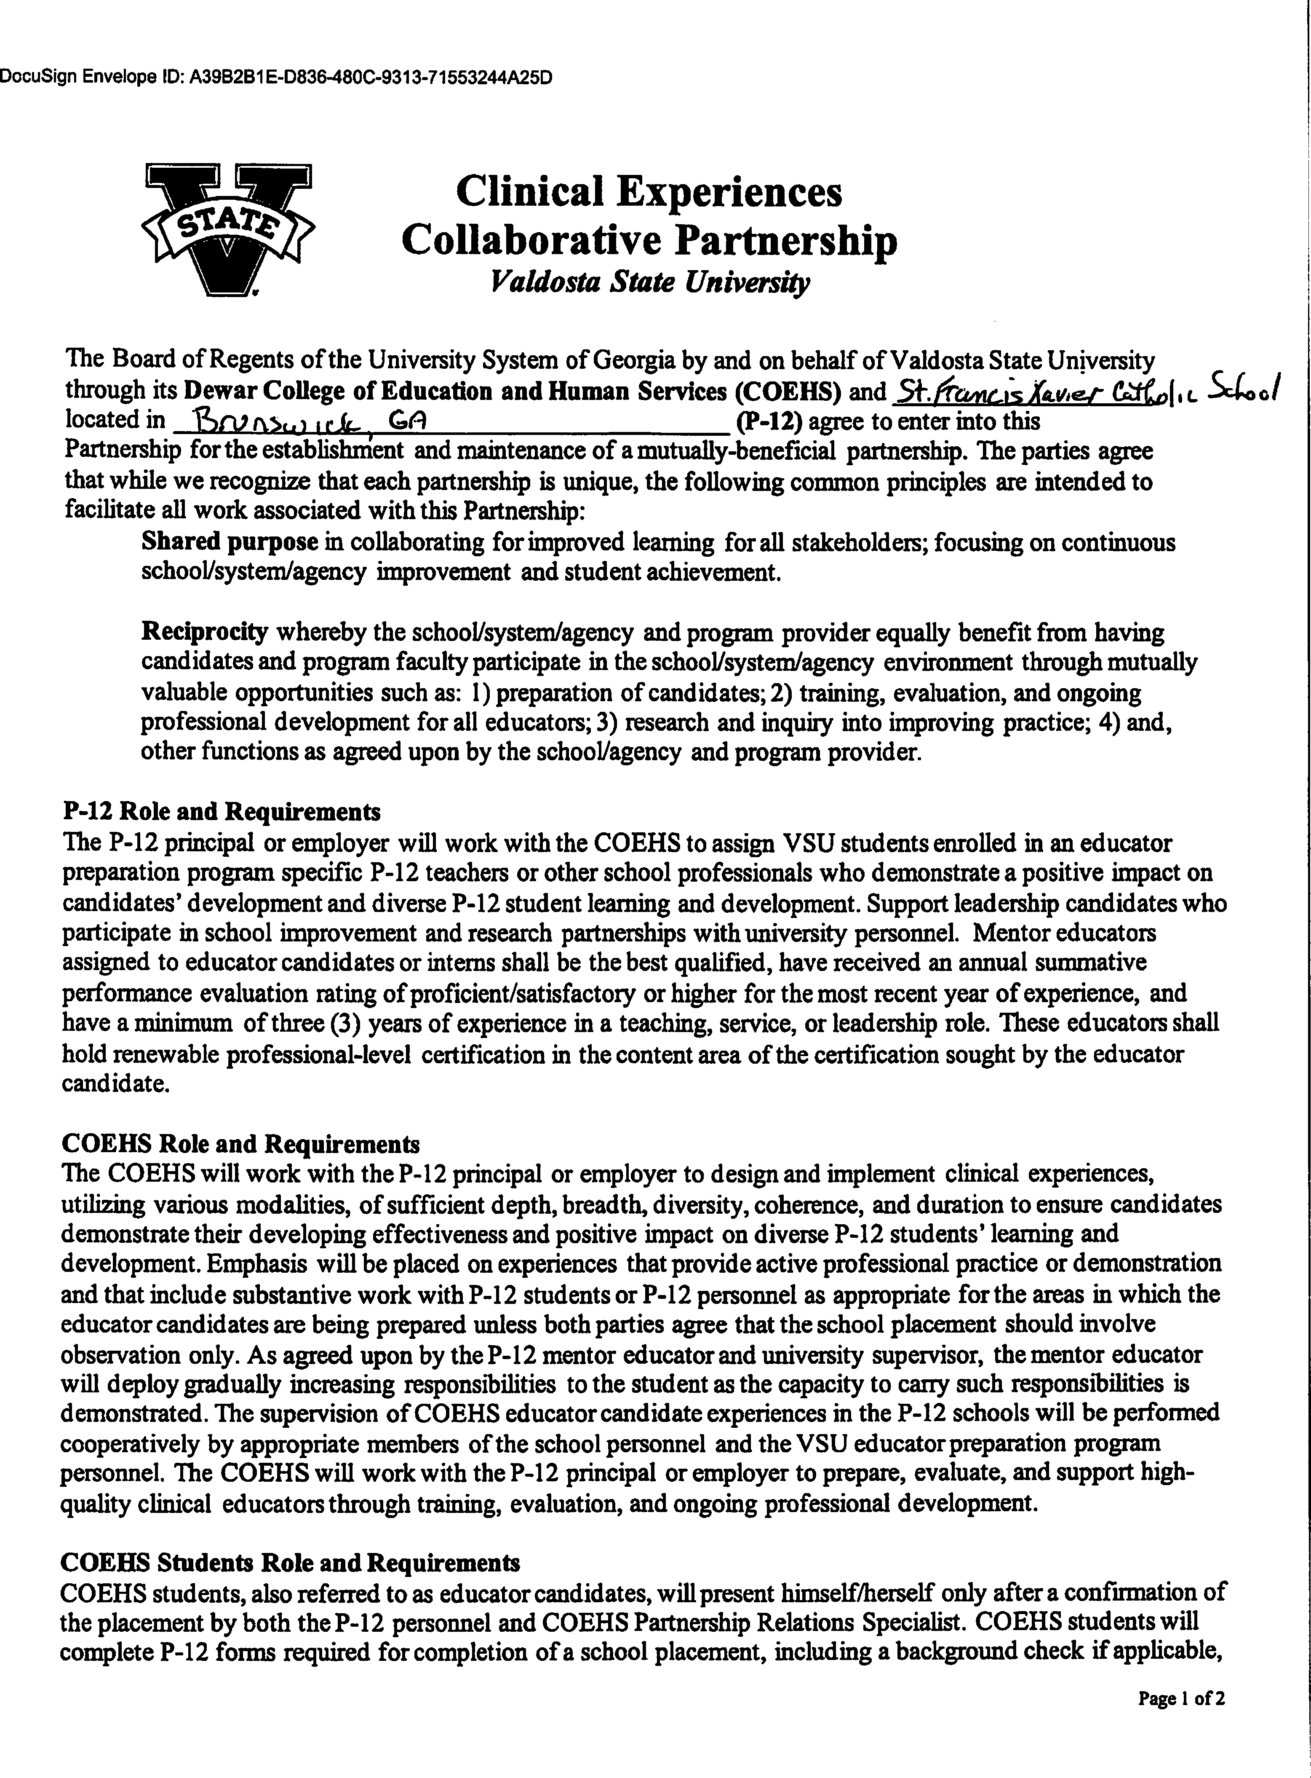

DocuSign Envelope ID: 231BD327-C21F-44A4-B303-C385173EB543

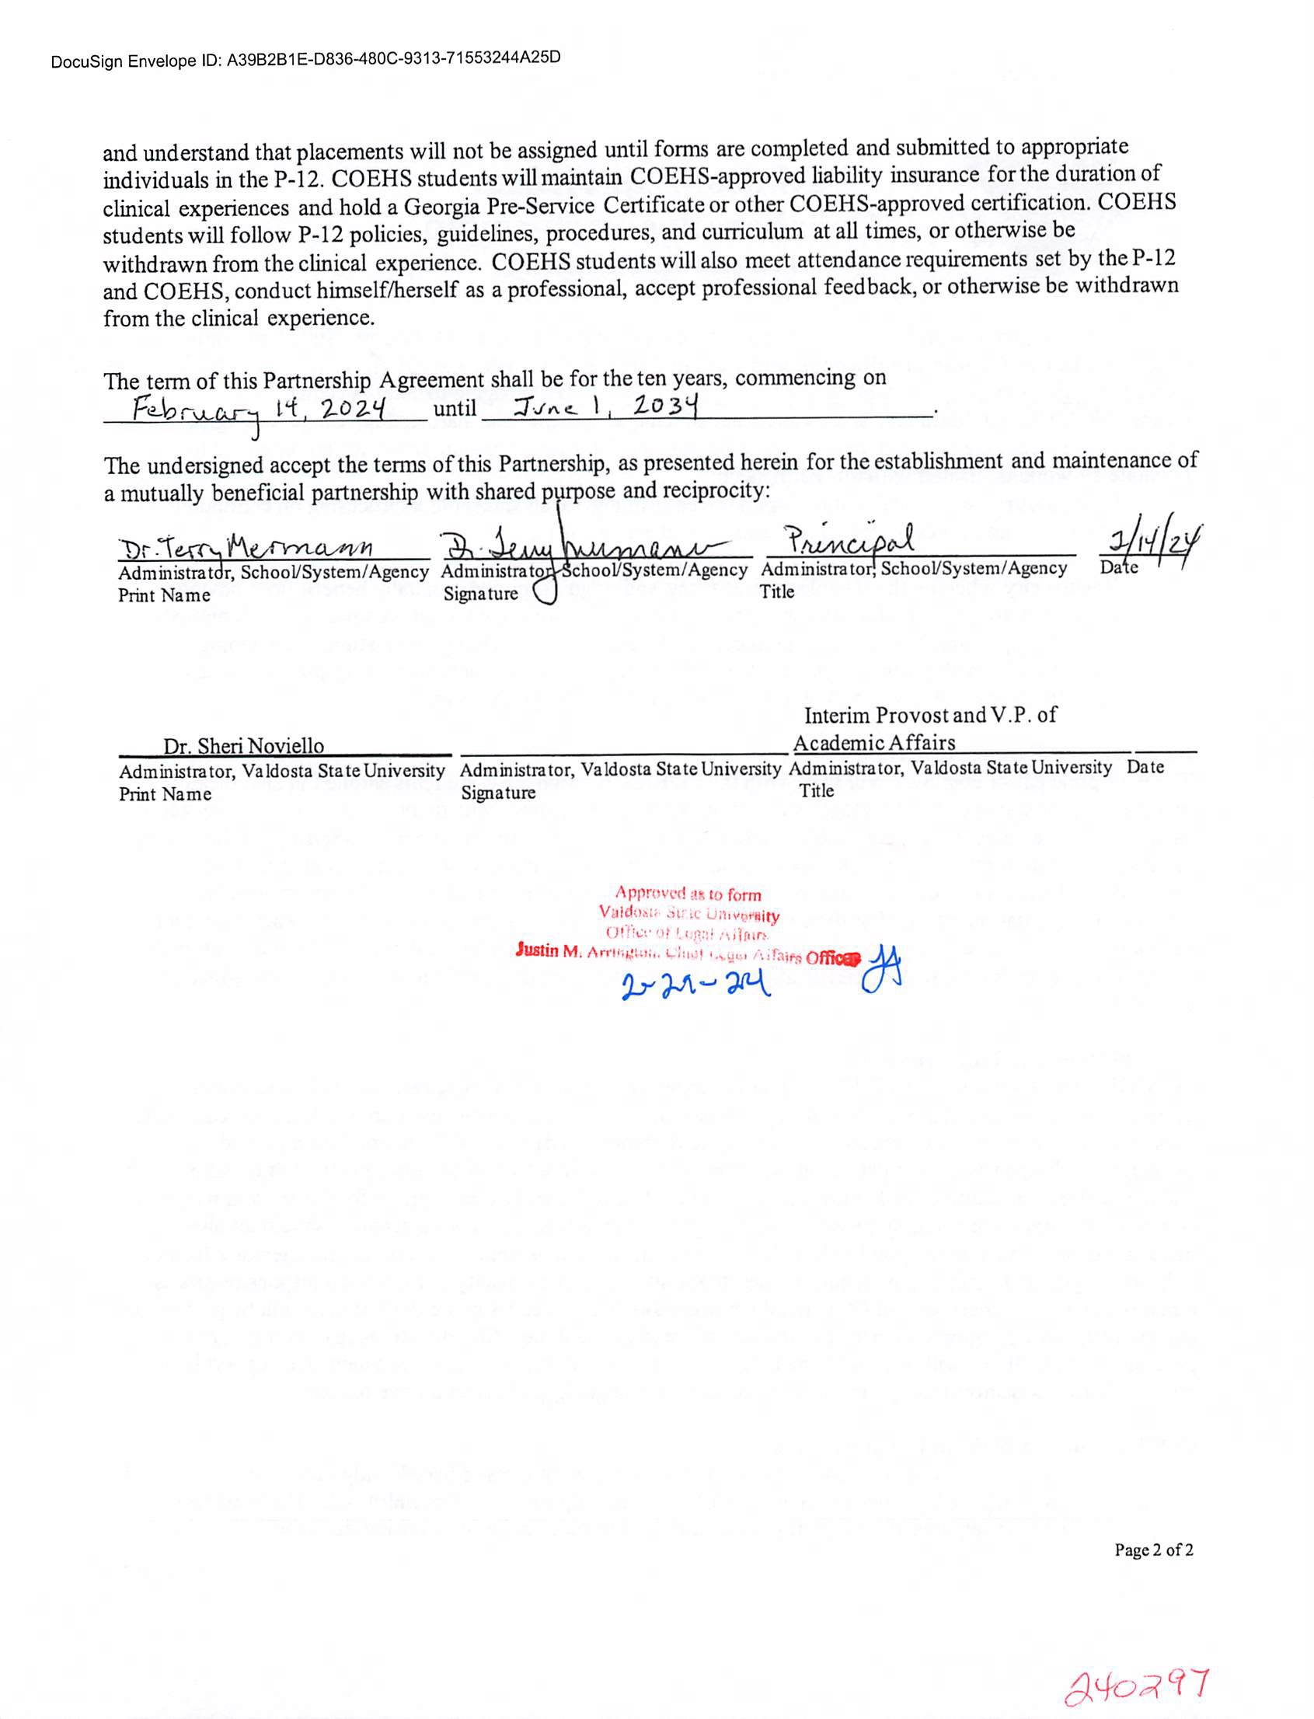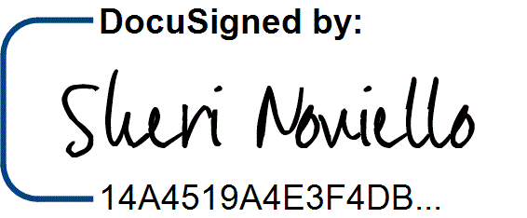

DocuSign Envelope ID: 231BD327-C21F-44A4-B303-C385173EB543

3/2/2024 | 2:45 AM EST