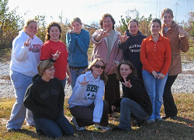
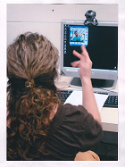
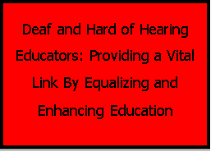
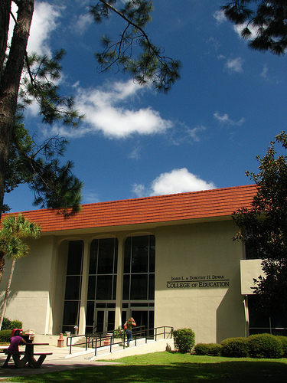
VALDOSTA STATE
UNIVERSITY
For Additional information contact:
Dr. Nanci A. Scheetz
Department of Middle Grades, Secondary, Reading & Deaf Education
1500 N. Patterson St.
Valdosta, GA 31698
Phone: 229-219-1322
Fax: 229-333-5963
Email: nascheet@valdosta.edu

Email: nascheet@valdosta.edu

The Special Education: Deaf and Hard of Hearing program is housed in the Department of Middle, Secondary, Reading and Deaf Education within the James L. and Dorothy H. Dewar College of Education at Valdosta State University. Students enroll in the program as traditional/on campus residents. All of the courses in the 5th year MED in Deaf Education are taught through distance learning.

Additional undergraduate programs offered by the Department include a BSED in ASL/Interpreting, and a minor in Deaf Studies.

Special Education: Deaf and Hard of Hearing

Special Education: Deaf and Hard of Hearing Program

VALDOSTA STATE
UNIVERSITY
Special Education: Deaf and Hard of Hearing Program

Core Curriculum
DEAF 2999 Entry to the Profession  ASLS 2110 American Sign Language I  ASLS 2120 American Sign Language II | 0  3  3
Junior Curriculum  Fall Semester | 14
ECSE 3010 Introduction to Assessment, Planning, and Instruction  ECSE 3210 Introduction to the Management of Learning  Environments  LITR 3110 Emergent Literacy  SPEC 3000 Serving Students with Diverse Needs  ECSE 3390 Early Childhood Inclusive Practicum and Seminar:  Pre-K-K | 3  3  3  3  2
Junior Curriculum  Spring Semester | 14
ECSE 3220 Intermediate Management of Learning Environments  ECSE 3490 Early Childhood Inclusive Practicum and Seminar:  Grades 1-3  ECSE 3020 Intermediate Assessment, Planning, and Instruction  LITR 3120 Early Literacy  LITR 3130 Developing Literacy | 3  2  3  3  3
Senior Curriculum  Fall Semester | 18
ASLS 3170 American Sign Language III  DEAF 3100 Orientation to Deafness & Language Learning  MATH 2008 Foundations of Numbers and Operations  READ 4550 Reading in the Content Areas  SPEC 3020 Applied Behavior Analysis for Teachers  SPEC 3040 Legal and Ethical Issues for Special Educators | 3  3  3  3  3  3
Senior Curriculum  Spring Semester | 16
ASLS 3180 American Sign Language IV  DEAF 3120 Learning, Cognition, and Social Development in Deaf  Children  SEED 4010 Integrating Technology in Secondary Education  MGED 3991 Differentiated Classroom for Middle Grades  MATH 3161 Mathematics for Early Childhood Teachers I  DEAF 4050 Manual Communication | 3  3  1  3  3  3

Special Education: Deaf and Hard of Hearing

Undergraduate
Deaf and Hard of Hearing Education

Special Education: Deaf and Hard of Hearing

Special Education: Deaf and Hard of Hearing

During the 5th year while enrolled as a graduate student, completers receive a Master’s degree in Special Education: Deaf and Hard of Hearing and are recommended for Georgia Educator Certification in Special Education: Deaf and Hard of Hearing. Teachers with this certificate are prepared to provide instruction or instructional support to students in PK-12 who are deaf or hard of hearing, including those with additional disabilities. Candidates in this program take coursework and field experiences in all content areas of early childhood (English / language arts, science, mathematics, social studies, the arts, health education, physical education, and reading) that satisfy the No Child Left Behind criteria for a “Highly Qualified” teacher in the state of Georgia.

The Special Education: Deaf and Hard of Hearing Program, was established by Valdosta State University to offer students an opportunity to obtain initial certification through the BSED in Deaf Education plus the 5th year traditional MED program. Candidates enrolled in the traditional program take extensive course work from two major departments: the Special Education/Early Childhood Department, and the Middle, Secondary, Reading and Deaf Education Department. Coursework in Early Childhood (PK-5), Middle Grades (5-8), Secondary (9-12), Reading, and in Deaf Education are woven throughout the three years of professional coursework.

