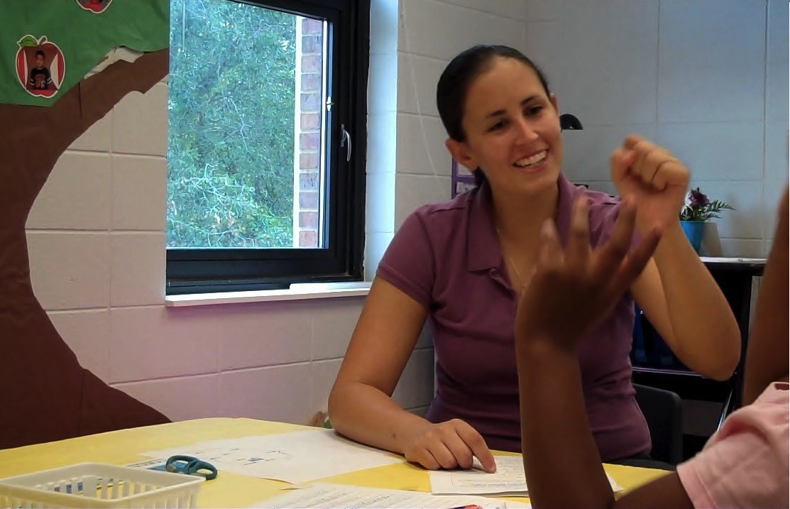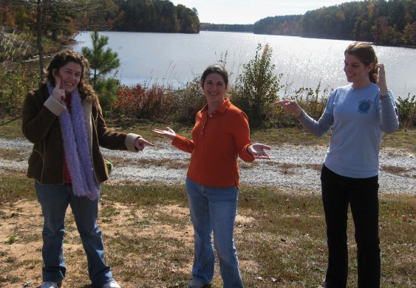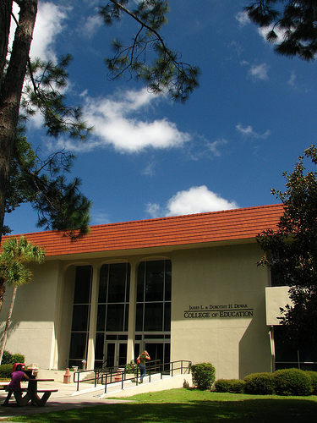

***For Additional information contact:***

**Dr. Nanci A. Scheetz**

**Department of Middle Grades, Secondary, Reading & Deaf Education**

**1500 N. Patterson St.**

**Valdosta, GA 31698**

**Phone: 229-219-1322**

**Fax: 229-333-5963**

**Email: nascheet@valdosta.edu**

**VALDOSTA STATE   
UNIVERSITY**

Deaf Studies Minor: An introduction to American Sign Language and Deaf culture

The Deaf Studies minor is housed in the Department of Middle, Secondary, Reading and Deaf Education within the James L. and Dorothy H. Dewar College of Education at Valdosta State University. Students can enroll in the program as traditional/on campus residents, or complete coursework through distance learning/video conferencing technology. The Depart­ment offers undergraduate programs in ASL/Interpreting, Deaf Education, Middles Grades Education, Reading and mas­ter's degree preparation in Special Education: Deaf and Hard of Hearing

**Deaf Studies Minor**

**VALDOSTA STATE   
UNIVERSITY**

Deaf Studies Minor

**Deaf Studies Minor**

### Donec consequat congue libero.

Nulla facilisi. Aenean sodales ligula ac elit. Fusce urna ipsum, tempor non, luctus vel, eleifend in, erat. Morbi venenatis augue in dolor. In a risus. In vitae felis quis pede malesuada sollicitudin. Vestibulum ante ipsum primis in faucibus orci luctus et ultrices posuere cubilia Curae; Sed et enim. In nisi. Proin vel libero. Donec sem. Phasellus lacus urna, congue in, congue quis, auctor ac, sem. Duis porta neque sit amet libero. Fusce vitae tortor venenatis diam pulvinar tristique. Suspendisse potenti. Donec non ipsum ut lectus ullamcorper vulputate. In blandit convallis purus. Ut bibendum.

**ASLS 2110 American Sign Language I**

**ASLS 2120 American Sign Language II**

**ASLS 3170 American Sign Language III**

**ASLS 3180 American Sign Language IV**

**DEAF 3100 Orientation to Deaf Education & Language Learning**

**DEAF 3150 Culture, History, and Literature**

**of Deaf People**

A minor in Deaf Studies was established by Valdosta State University to provide students with knowledge and skills in American Sign Language (ASL) as well as Deaf Culture, history, literature and linguistics.

Students pursuing a minor in Deaf Studies are exposed to the uniqueness of ASL as a world language while acquiring cultural knowledge that will enable them to successfully interact with the American Deaf community. The curriculum is designed to promote a cultural and linguistic understanding of Deaf individuals while encouraging students to analyze existing stereotypes pertaining to this population, so they in turn, can effectively educate hearing members of society.

**Deaf Studies**

**Deaf Studies**

Students enrolled in programs such as Sociology, Psychology, Social Work, Counseling, Communication Sciences and Disorders, Criminal Justice, Anthropology, a foreign language, Fine Arts (Music, Dance, Theater, and Film), Communications, Education, Exercise Science, Business, Nursing, Mass Media, and other fields of study are highly encouraged to consider this minor.

**Deaf Studies**

**Minor**

**Deaf Studies**

***Curriculum (18 Hours)***

Deaf Studies Minor: An introduction to American Sign Language and Deaf culture