UNITED STATES AIR FORCE

OFFICER QUALIFYING TEST
(AFOQT)
INFORMATION PAMPHLET

August 1, 2014

AFOQT Information Pamphlet

Introduction

The Air Force Officer Qualifying Test (AFOQT) measures aptitudes used to select candidates for officer commissioning programs and specific commissioned officer training programs. The AFOQT consists of 12 subtests. Subtest scores are combined to generate composite scores used to help predict success in certain types of Air Force training programs.

2014 Updates: Introduction of Form T

AFOQT Form T is effective August 1, 2014. Some significant changes have been made to the test based on feedback from an Air Force-wide survey in which officers identified abilities and aptitudes critical for effectiveness as an officer. Some of those changes include:

Updated test questions were introduced throughout the AFOQT.

Reading Comprehension was added and contributes to the Verbal and Academic Aptitude Composites. This subtest incorporates the types of written materials required in officer Professional Military Education (PME).

Situational Judgment was added to evaluate judgment in responding to the types of interpersonal situations frequently encountered by officers.

Instrument Comprehension was updated with enhanced graphics based on modern aircraft.

General Science was revised with a focus on the physical sciences and was therefore renamed to Physical Science.

Composite Descriptions

The AFOQT composites and the kinds of knowledge and abilities they measure are described in the sections that follow.

Pilot. This composite measures some of the knowledge and abilities considered necessary for successful completion of manned and unmanned pilot training. The Pilot composite includes subtests which measure quantitative ability, the ability to determine aircraft attitude from instruments, knowledge of aeronautical concepts, and perceptual speed. This composite is used in combination with the Test of Basic Aviation Skills (TBAS) and flying hours to determine your overall Pilot Candidate Selection Method (PCSM) score.

- Combat Systems Officer (CSO). This composite (previously called Navigator-Technical) measures some of the knowledge and abilities considered necessary for successful completion of CSO training. The CSO composite shares some subtests with the Pilot composite, with the exception that measures of an ability to determine aircraft attitude and knowledge of aeronautical concepts are not included. However, subtests are added measuring verbal aptitude and spatial ability.

- Air Battle Manager (ABM). This composite measures some of the knowledge and abilities considered necessary for successful completion of ABM training. The ABM composite shares some subtests with the Pilot composite, including measures of an ability to determine aircraft attitude, knowledge of aeronautical concepts, perceptual speed, and quantitative ability. However, like the CSO composite, subtests are added measuring verbal aptitude and spatial ability.

- Academic Aptitude. This composite measures verbal and quantitative knowledge and abilities. The Academic Aptitude composite combines all subtests that make up the Verbal and Quantitative composites.

- Verbal. This composite measures verbal knowledge and abilities. The Verbal composite has subtests which measure the ability to reason, make inferences, and recognize relationships among words.

- Quantitative. This composite measures quantitative knowledge and abilities. The Quantitative composite shares subtests with the CSO composite discussed above and has subtests which measure the ability to understand and reason with arithmetic relationships and to use mathematical terms, formulas, and relationships.

- Situational Judgment. This composite measures judgment and decision-making in responding to the types of interpersonal situations often encountered by junior USAF officers. Test questions are based on real scenarios experienced by junior officers (O1-O3) requiring core competencies of Integrity and Professionalism, Leadership, Resource Management, Communication, Innovation, and Mentoring. Scored relative to the consensus judgment of identified high-potential USAF officers, test questions were selected for inclusion in the composite based on statistical relationships of scores to cadet outcomes in Basic Officer Training and Field Training.

AFOQT subtests and composites (including updated subtests effective August 1, 2014 and rated composites effective February 14, 2013) are shown in Table 1. Table 2 is the testing schedule for the AFOQT Form T.

TABLE 1. CONSTRUCTION OF AFOQT COMPOSITES

Subtest | Items | Pilot | CSO | ABM | Academic | Verbal | Quant | Situational Judgment
Verbal Analogies | 25 |  |  | X | X | X
Arithmetic Reasoning | 25 |  |  |  | X |  | X
Word Knowledge | 25 |  | X |  | X | X
Math Knowledge | 25 | X | X | X | X |  | X
Reading Comprehension | 25 |  |  |  | X | X
Situational Judgment Test | 50 |  |  |  |  |  |  | X
Self-Description Inventory | 240
Physical Science | 20
Table Reading | 40 | X | X | X
Instrument Comprehension | 25 | X |  | X
Block Counting | 30 |  | X | X
Aviation Information | 20 | X |  | X
Note. Rated composites are in bold.
TABLE 2. TESTING SCHEDULE

 | Administration  Time and Breaks  (In Minutes) | Testing Time (In Minutes) | Total Time  (In Minutes)
Part A Pretest Activities | 10 |  | 10
Verbal Analogies | 1 | 8 | 9
Arithmetic Reasoning | 1 | 29 | 30
Word Knowledge | 1 | 5 | 6
Math Knowledge | 1 | 22 | 23
Reading Comprehension | 1 | 38 | 39
Break | 10 |  | 10
Situational Judgment Test | 1 | 35 | 36
Self-Description Inventory | 1 | 45 | 46
Demographics for Part A and B Answer Sheets | 15 |  | 15
Part A Time Required | 42 Minutes | 3 Hours, 2 Minutes | 3 Hours, 44 Minutes
Break | 15 |  | 15
Part B Pretest Activities | 3 |  | 3
Physical Science | 1 | 10 | 11
Table Reading | 2 | 7 | 9
Instrument Comprehension | 3 | 5 | 8
Block Counting | 2 | 4.5 | 6.5
Aviation Information | 1 | 8 | 9
Collection of Materials | 2 |  | 2
Part B Time Required | 29 Minutes | 34.5 Minutes | 1 Hour, 3.5 Minutes
TOTAL TIME REQUIRED | 1 Hour, 11 Minutes | 3 Hours, 36.5 Minutes | 4 Hours, 47.5 Minutes

What to Expect

When you arrive for test administration, you will be given complete and specific instructions on how to take the test. The number of questions in each of the subtests and the time you will be given to complete each subtest will vary from subtest to subtest. On many of the subtests, you will likely have more than enough time to answer all the questions. On several subtests, however, you may not finish. Don’t worry if this happens, since many people do not finish these subtests. Just work as quickly and accurately as you can.

All of the subtests have multiple-choice questions with four or five possible answers. Except for the Self-Description Inventory and Situational Judgment Test, each question has only one correct or best answer. If you are not sure of the answer to a question, make a selection anyway, even if you have to guess. Your score on the AFOQT will be based on the number of correct answers you select. You will not lose points or be penalized for guessing.

You will be instructed not to make any marks in your actual test booklet. You will record all of your answers using a pencil on a separate answer sheet that will be scored by a machine. Scratch paper will be provided for you to use when you need to do any calculations.

Before you take some of the subtests, you will have the opportunity to answer some practice questions to be sure that you understand what you are to do on the test. If you are not sure what you are supposed to be doing, ask your test administrator or proctor for help before you start answering the actual test questions. However, test administrators or proctors can only assist you in understanding the directions. They cannot give you guidance concerning test questions and answers or test taking strategy.

It is important that you get a good night’s rest before taking the test. You will be asked before you take the test if you are physically able to take the AFOQT. If you do not feel that you are able to take the test at this time, inform the test administrator and you will be scheduled to take the AFOQT at a later date. Be relaxed, follow instructions, read each question carefully, and do the best you can.

How to Use This Pamphlet

This pamphlet is designed to familiarize you with examples of the types of questions you will find on each AFOQT subtest. This pamphlet will not help you “study” for the AFOQT. In fact, because the AFOQT is a test of your general knowledge in a large number of subject areas, there is no “best way” to study for it. The format and style of the questions in this pamphlet are very similar to that of the actual tests, although most items in the AFOQT will prove to be more difficult. Taking these practice subtests will give you an idea of what the real test will be like.

For each question, be sure to pick the best one of the possible answers listed. When you have decided which one of the choices is the best answer, write it on a separate piece of paper. The correct answers to the sample questions in this pamphlet are in the last page of this pamphlet (Table 3). If you have any questions about the AFOQT after reading this pamphlet, please discuss them with your test examiner, recruiter, or detachment personnel.

PART A.1 - Verbal Analogies

DIRECTIONS: This part of the test measures your ability to reason and see relationships among words. You are to choose the option that best completes the analogy developed at the beginning of each statement.

- Rural is to sparse as urban is to 1-A noisy.
1-B crowded. 1-C hurried.
1-D suburban. 1-E suave.

- Infancy is to childhood as engagement is to 2-A discussion.
  - love.
  - bride.
  - ring.
  - marriage.

- Odd is to unusual as amusing is to 3-A humorous.
  - sad.
  - hilarious. 3-D flippant.
3-E commonplace.

- Waterfall is to cascade as 4-A river is to fish.
  - ocean is to cross.
  - stream is to meander. 4-D hurricane is to warn. 4-E lake is to sail.

- Cocoon is to butterfly as 5-A web is to spider.
  - den is to lion.
  - pouch is to kangaroo. 5-D covey is to quail.
5-E cave is to bear.

PART A.2 - Arithmetic Reasoning

DIRECTIONS: This part of the test measures your ability to use arithmetic to solve problems. Each problem is followed by five possible answers. You are to decide which one of the five choices is correct.

- A car traveled at 60 miles per hour for 2½ hours. If one inch equals 20 miles on a map, how far has the car traveled on the map?
  - 7.5 inches
  - 8.3 inches
  - 9.7 inches
  - 10.5 inches
  - 15.0 inches

- What is the volume of a container that is 22 feet long, 15 feet wide, and 10 feet high?
2-A 1369 cu. ft.
2-B 1500 cu. ft.
2-C 1650 cu. ft.
2-D 2209 cu. ft.
2-E 3300 cu. ft.

- A sport’s fan spent a total of $450 on baseball tickets. If only $4 and $5 tickets were bought, and there was an equal number at each price, how many $5 tickets were bought?
3-A | 45
3-B | 50
3-C | 56
3-D | 72
3-E | 90
- A student spent 2 hours studying, 1 hour doing laundry, and 1 ½ hours watching television. What percentage of time was spent doing laundry?
  - 44 percent
  - 37 percent
  - 33 percent
  - 22 percent
  - 11 percent

- If a train can travel 405 miles in 4 ½ hours, how far can it travel in 30 minutes?
5-A 45 miles
  - 53 miles
  - 60 miles
  - 81 miles
  - 90 miles

PART A.3 - Word Knowledge

DIRECTIONS: This part of the test measures your knowledge of words and their meanings. For each question, you are to choose the word below that is closest in meaning to the capitalized word above.

- REPLENISH 1-A furnish
  - provide
  - refill
  - stock
  - refinish

- PATHETIC
2-A sorrowful 2-B dejected 2-C regretful 2-D pitiful
2-E depressed

- BLUNDER 3-A err
  - sneak
  - omit
  - confuse 3-E shuffle

- MEDIATOR
4-A interviewer 4-B meddler
4-C peacemaker 4-D coach
4-E defender

- LUCIDITY 5-A clarity
5-B brightness 5-C greed
5-D delirium 5-E speed

PART A.4 - Math Knowledge

DIRECTIONS: This part of the test measures your knowledge of mathematical terms and principles.
Each problem is followed by five possible answers. You are to decide which one of the five choices is correct.

1. | 17 |  | 6 | 15
 | ––  20 | + | –––  100 | + –––  50 | is equal to

1-A | 43/50
1-B | 111/100
1-C | 121/100
1-D | 83/50
1-E | 289/25
- If 5 v – u = – 2 and – v + 9 u = 18, then the simultaneous solution of the given equation is:

2-A u = 3, v = 9
2-B u = 2, v = 0
2-C u = 1, v = – 9
2-D u = – 2, v = – 36
2-E u = 3, v = – 15
- Which of the following statements is false? A triangle can have
3-A three equal angles.
  - one obtuse angle.
  - three equal sides.
3-D two right angles.
3-E three acute angles.
- The value – 1/9 81 is equal to
  - 0
  - –1
  - 1
  - 9
4-E –9
- The factors of 30x² – 30 are
5-A (5x – 6), (6x + 5)
5-B (15x + 5), (2x – 6)
5-C (5x – 6), (6x – 5)
5-D (30x – 5), (x + 6)
5-E (5x + 5), (6x – 6)

Part A.5 - Reading Comprehension

DIRECTIONS: This part of the test measures your ability to read and understand written material. Each passage is followed by a series of multiple-choice questions. You are to choose the option that best answers the question based on the passage. No additional information or specific knowledge is needed.

One of the fears haunting policy makers is the appearance of a pathogen, either manmade or natural, able to devastate mankind, as the “Black Death” did in the Middle East and Europe in the middle of the Fourteenth Century. Within barely a year, approximately a third of Europe’s population died. The second and third-order effects of the pandemic on society, religion, and economics were devastating. In effect, the Black Death destroyed the sureties undergirding Medieval European civilization.
5

It is not likely that a pandemic on this scale will devastate mankind over the next two decades. Even though populations today are much larger and more concentrated, increasing the opportunities for a new pathogen to spread, the fact that mankind lives in a richer world with greater knowledge of the world of microbes, the ability to enact quarantines, a rapid response capability, and medical treatment suggest that authorities could control even the most dangerous of pathogens. The crucial element in any response to a pandemic may be the political will to impose quarantine.
15
10

The rapid identification and response to the 2009 H1N1 flu strain and the rapid termination of the 2003 Severe Acute Respiratory Syndrome (SARS) pandemic illustrate the seriousness with which medical authorities view these. In the case of SARS, after initial reports surfaced from East Asia in February of an atypical respiratory disease, medical authorities reported more than 8,000 cases in 30 different countries. The disease itself was highly contagious and life-threatening: almost 10% of reported cases died. However, once doctors identified the disease, the combined efforts of local, national, and international authorities contained it within five months. Newly reported cases increased rapidly in March and April 2003, peaked in early May, and rapidly declined thereafter.
25
20

The H1N1 and SARS examples do not mean, however, that the threat of social disorder or disruption originating from a viral source requiring Joint Force capabilities is nonexistent. A repetition of the 1918 influenza pandemic, which led to the deaths of millions world-wide, would have the most serious consequences for the United States and the world politically as well as socially. The dangers posed by the natural emergence of a disease capable of launching a global pandemic are serious enough, but the possibility exists also that a terrorist organization might acquire a dangerous pathogen.
30

The deliberate release of a deadly pathogen, especially one genetically engineered to increase its lethality or virulence, would present greater challenges than a naturally occurring disease like SARS. While the latter is likely to have a single point of origin, terrorists could seek to release the pathogen at several different locations in order to increase the rate of transmission across a population. This would seriously complicate both the medical challenge of bringing the disease under control and the security task of fixing responsibility for its appearance.
40
35

The implications for the Joint Force of a pandemic as widespread and dangerous as that of 1918 would be profound. American and global medical capabilities would soon find themselves overwhelmed. If the outbreak spreads to the United States, the Joint Force might have to conduct relief operations in support of civil authorities that, consistent with meeting legal prerequisites, could go beyond assisting in law enforcement and maintaining order. Even as Joint Force commanders confronted an array of missions, they would also have to take severe measures to preserve the health of their forces and protect medical personnel and facilities from public panic and dislocations. Thucydides captured the moral, political, and psychological dangers that a global pandemic would cause in his description of the plague’s impact on Athens: “For the catastrophe was so overwhelming that men, not knowing what would happen next to them, became indifferent to every rule of religion or of law.”
50
45

- The primary purpose of the passage is to

1-A Describe the impact of the “Black Death” on Medieval European civilization
1-B Compare and contrast the threat of manmade pathogens to that of natural pathogens
1-C Identify the potential threats of future pandemics and implications for the Joint Force
1-D Provide a comprehensive historical account of pandemics from the Fourteenth Century to 2009
1-E Summarize the collaborative role of medical authorities and Joint Force commanders in responding to pandemics

- In the second paragraph, “scale” most nearly means

2-A Ranking
2-B Hierarchy
2-C Magnitude
2-D Balance
2-E Weight

- As inferred from the passage, which of the following factors made the “Black Death” pandemic LESS devastating?

3-A unwillingness to isolate infected individuals
3-B substantial societal wealth
3-C large population in the region
3-D availability of appropriate medical treatment
3-E sparse population density

- The H1N1 and SARS pandemics are discussed primarily to

4-A Illustrate the potential threat of pandemics spreading across national borders
4-B Suggest that capabilities of the Joint Forces could have limited H1N1/SARS fatalities
4-C Contrast the efficacy of East Asian medical authorities with those in the United States and Europe
4-D Demonstrate the success of contemporary medical authorities in containing some pandemics
4-E Show that these recent pandemics are atypical of those caused by other respiratory diseases

- With which one of the following claims about pandemics would the author most likely agree?

5-A The political will to impose quarantine will be sufficient to contain future pandemics
5-B The Joint Force will need to assist medical authorities in response to a pandemic only if terrorists are involved
5-C Policy makers fears of potential devastation exaggerate the likely consequences of a future pandemic
5-D The Joint Force should be restricted to law enforcement or peace-keeping duties in response to a U.S. pandemic
5-E Medical advances that could allow terrorists to genetically engineer pathogens make the potential threat of pandemic greater than during Medieval times

PART A.6 - Situational Judgment

DIRECTIONS: This part of the test measures your judgment in responding to interpersonal situations similar to those you may encounter as an officer. Your responses will be scored relative to the consensus judgment across experienced U.S. Air Force officers.

For each situation, you must respond to two questions. First, select which one of the five actions listed you judge the MOST EFFECTIVE action in response to the situation. Then, select which one of the five actions listed you judge the LEAST EFFECTIVE action in response to the situation. [NOTE: Although some actions may have been judged equally effective or equally ineffective by experienced officers, select only one action (A-E) for each question.]

Situation I. You have recently been assigned to lead a section comprised of experienced subordinates, but you do not have a full understanding of the mission and tasks. Your subordinates are not helpful when you solicit ideas and information from them. You know it is necessary for you to understand your job and the other section members’ jobs in order to effectively lead your section and accomplish the mission.

Possible actions:
- Contact the superior who assigned you to the section for further guidance.
- Contact the individual previously assigned to the section for guidance.
- Meet privately with the most senior subordinate to discuss the section’s mission.
- Meet individually with each subordinate to get to know them personally.
- Call a section meeting, and emphasize that you need everyone's cooperation in order to help the section succeed.

1. Select the MOST EFFECTIVE action (A-E) in response to the situation.
2. Select the LEAST EFFECTIVE action (A-E) in response to the situation.

Situation II. You are in charge of a project supported by people who do not fall directly under your supervision, including a civilian engineer. The engineer always provides update briefings in your meetings with the commander, who is superior in authority to the engineer and your immediate supervisors. When answering technical questions about the project, the engineer often leaves out relevant facts. You recognize the engineer is filtering his responses, sometimes to the point of being untruthful.

Possible actions:
- Speak up during the meeting to present the full, unfiltered information yourself.
- Immediately after the meeting, discuss your concerns privately with the engineer.
- Immediately after the meeting, notify the engineer’s supervisor of your concerns.
- Immediately after the meeting, notify your supervisor of your concerns to seek advice.
- Immediately after the meeting, meet privately with the commander to present the full, unfiltered information.

3. Select the MOST EFFECTIVE action (A-E) in response to the situation.
4. Select the LEAST EFFECTIVE action (A-E) in response to the situation.

Part A. 7 - Self-Description Inventory

DIRECTIONS: This inventory records your personal style and attitudes. There are no right or wrong answers – the goal is to record your first impressions and identify Air Force jobs where people who respond like you find the work satisfying. The inventory consists of a list of statements. Read each statement and, based on your first impression,
record how well each one describes you.

Look at the sample statement below:

S1. I enjoy reading poetry.

Indicate your agreement with the statement using the scale below.

A | B | C | D | E
Strongly  Disagree | Moderately  Disagree | Neither Agree  nor Disagree | Moderately  Agree | Strongly  Agree

If you strongly agree that the statement describes you, select response E on the scale. If you strongly disagree, select response A on the scale. You would select B, C, or D to indicate other levels of agreement.

You should work quickly and reply to all statements. Give your first impression about how well each statement describes you. Don't spend a long time deciding what your answer should be. Answer all statements, even if you're not sure of your answer.

The 10 statements below are representative of the types of statements in the inventory.

  - I always try to finish what I start.

  - I generally get along well with most people.

  - I get nervous if I have to speak in public.

  - People often get upset with me for now showing up on time.

  - I like to listen to many different kinds of music.
  - Usually I let my work goals take priority over my personal interests.

  - I am not comfortable supervising others.

  - I am pleased when friends drop in to see me.

  - I don’t like to be involved in group activities.

  - I have higher work standards than do most people.

PART B.1 - Physical Science

DIRECTIONS: This part of the test measures your knowledge in the area of science. Each of the questions or incomplete statements is followed by five choices. You are to decide which one of the choices best answers the question or completes the statement.

In the International System of Units, a measurement for mass is

1-A a meter.

1-B a henry.

1-C an ampere.

1-D a kilometer.

1-E a kilogram.

A razor blade will rest on the surface of water in a shallow depression caused by its weight because of

2-A surface tension.

2-B osmosis.

2-C homogeneity.

2-D dispersion.

2-E desalinization.

The bending of light as it passes from one material into another is known as

3-A inertia.

3-B adhesion.

3-C refraction.

3-D deflection.

3-E displacement.

Resistance is the tendency for a material to oppose the flow of electrons and is measured in

4-A currents.

4-B amperes.

4-C ohms.

4-D watts.

4-E volts.

In order for a lunar eclipse to take place, the

5-A moon must be between the sun and the Earth.

5-B moon must be in the early crescent phase.

5-C Earth must be between the sun and the moon.

5-D Earth’s axis of rotation must point toward the moon.

5-E Earth and moon must be on opposite sides of the sun.

PART B.2 - Table Reading

DIRECTIONS: This part of the test measures your ability to read a table quickly and accurately. Look at the table below. Notice that the X values appear at the top of the table and the Y values are shown on the left side of the table. The X values are the column values. The Y values are the row values. For each test question, you are given an X and a Y value. Your task will be to find the block where the column and row intersect, note the number that appears there, and then find this number among the five answer options.

X VALUE
25 | 26 | 28 | 30 | 31 | 32 | 33
26 | 28 | 30 | 32 | 33 | 34 | 35
27 | 29 | 31 | 33 | 35 | 36 | 37
29 | 30 | 32 | 34 | 36 | 37 | 38
30 | 32 | 33 | 35 | 37 | 38 | 40
31 | 33 | 34 | 36 | 38 | 39 | 41
32 | 34 | 35 | 37 | 39 | 40 | 42

Y VALUE  X Y |  |  | +3 | -3 |  | -2 | -1 | 0 | +1 |  | +2 |  | +3
 |  |  | +2
 |  |  | +1
 |  |  | 0
 |  |  | -1
 |  |  | -2
 |  |  | -3
 |  |  |  |  | A |  | B | C |  | D |  | E
1. | +1 | +2 |  |  | 35 |  | 36 | 30 |  | 33 |  | 34
2. | 0 | -3 |  |  | 29 |  | 37 | 39 |  | 30 |  | 36
3. | -2 | +3 |  |  | 26 |  | 32 | 34 |  | 28 |  | 40
4. | -1 | 0 |  |  | 33 |  | 30 | 35 |  | 36 |  | 32
5. | +3 | -1 |  |  | 41 |  | 27 | 40 |  | 38 |  | 39

PART B.3 - Instrument Comprehension

DIRECTIONS: This part of the test measures your ability to determine the position of an airplane in flight from reading instruments showing its compass direction heading, amount of climb or dive, and degree of bank to right or left. Each problem consists of two dials and four answer options. In each problem, the left-hand dial is labeled ARTIFICIAL HORIZON. On the face of the dial a stationary indicator in the center represents the airplane, while the positions of the heavy black line, black pointer, and markings along the outer edge vary with changes in the position of the airplane in which the instrument is located.

The heavy black line represents the HORIZON LINE and tilts as the airplane is banked. The white pointer shows the degree of BANK to the right or left. The shaded portions of the instrument face represent the ground.

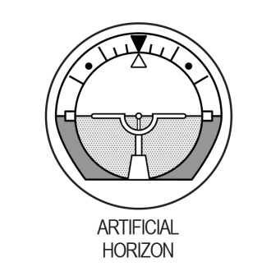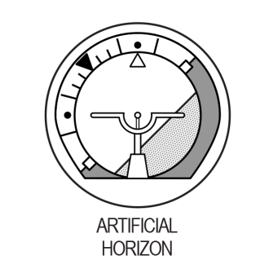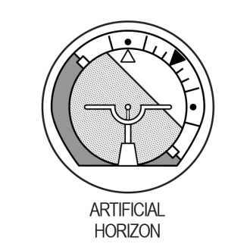
Dial 1
Dial 3
Dial 2

If the airplane is neither climbing nor diving, the horizon line is directly on the airplane indicator, as in dial 1 above. If the airplane has no bank, the white pointer is seen to point to the black pointer. Dial 1 shows an airplane in straight and level flight.

If the airplane is climbing, the airplane indicator is seen between the horizon line and the black pointer, as in dial 2 above. The greater the amount of climb, the greater the distance between the horizon line and the airplane indicator. If the airplane is banked to the pilot’s right, the white pointer is seen to the right of the black pointer. Dial 2 shows an airplane climbing and banked 45° to the pilot’s right.

If the airplane is diving, the horizon line is seen between the airplane indicator and the black pointer, as in dial 3 above. The greater the amount of dive, the greater the distance between the horizon line and the airplane indicator. If the airplane is banked to the pilot’s left, the white pointer is seen to the left of the black pointer. Dial 3 shows an airplane diving and banked 45° to the pilot’s left.

In each problem the right-hand dial is labeled COMPASS. On this dial, the arrow shows the compass direction in which the airplane is headed. Dial 4 shows the airplane headed north, dial 5 shows it headed west, and dial 6 shows it headed northwest.

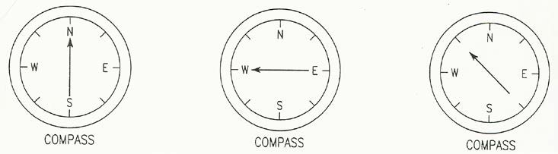

Dial 4 Dial 5 Dial 6

Each problem consists of two dials and four airplanes in flight. Your task is to determine which one of the four airplanes is MOST NEARLY in the position indicated by the two dials. YOU ARE ALWAYS LOOKING NORTH AT THE SAME ALTITUDE AS THE FOUR AIRPLANES. EAST IS ALWAYS TO YOUR RIGHT AS YOU LOOK AT THE PAGE. In sample question X below, the dial labeled ARTIFICIAL HORIZON shows that the airplane is NOT banked, and neither climbing nor diving. The COMPASS shows that it is headed southeast. The only one of the four airplanes that meets these specifications is in the box lettered C; so, the answer to sample question X is C. Note that B is a rear view, whereas D is a front view. Note also that A is banked to the right and that B is banked to the left.

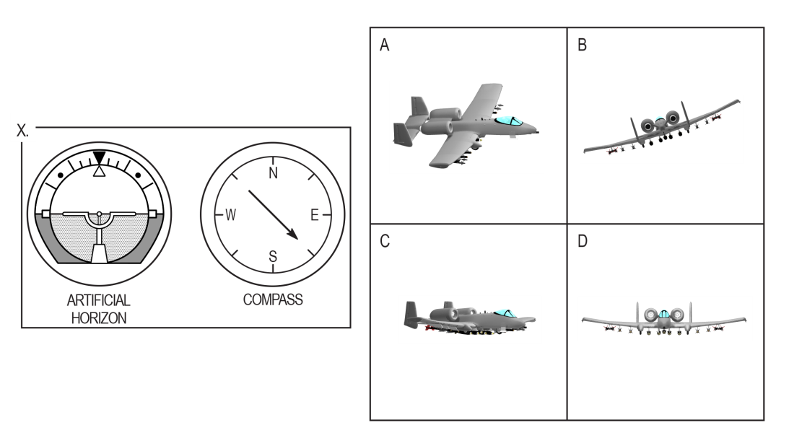
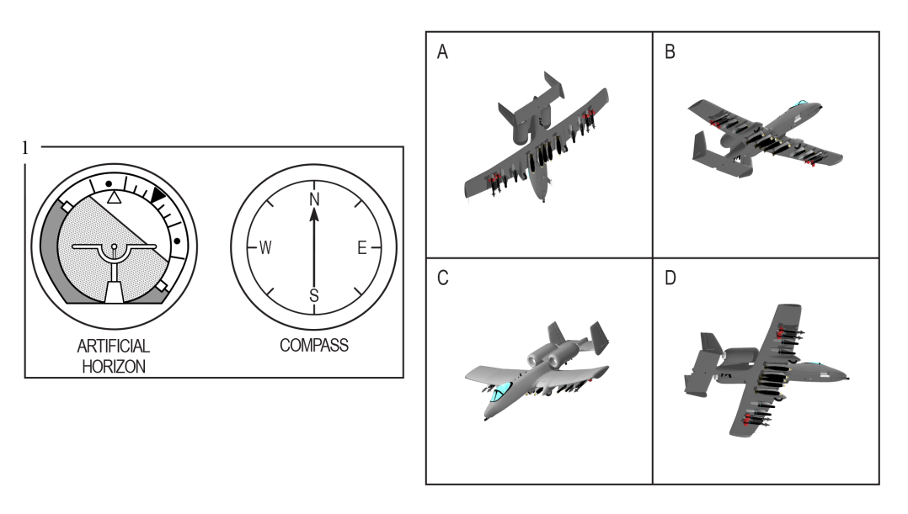

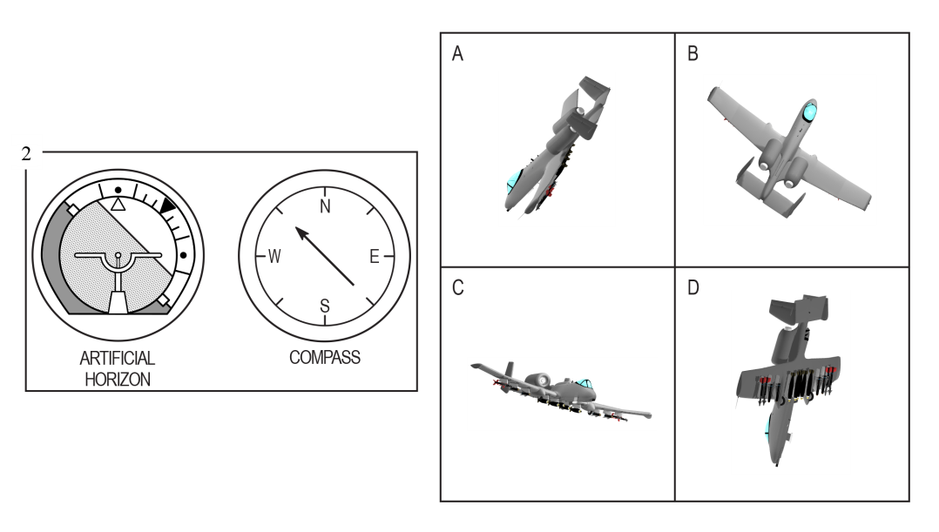

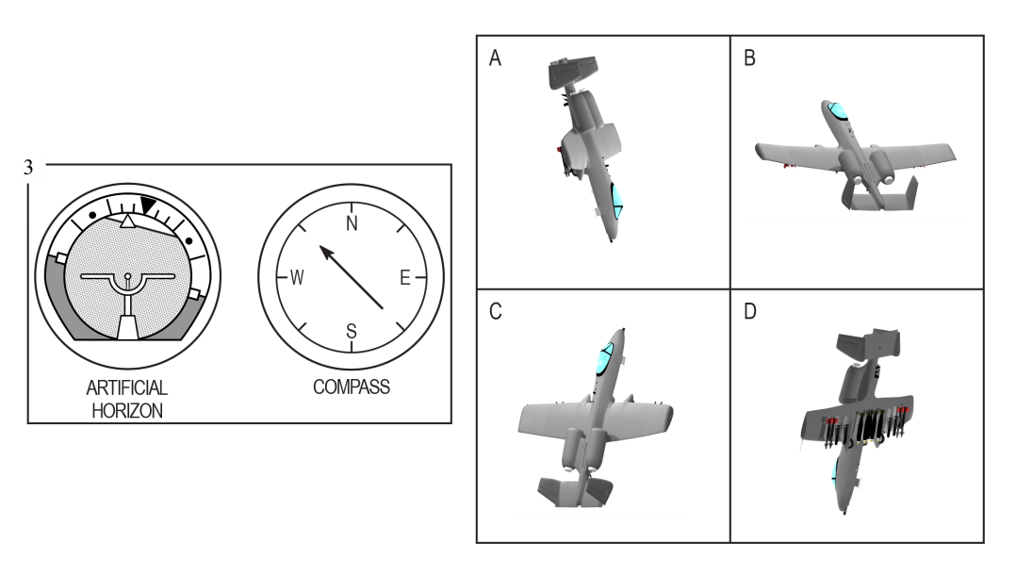

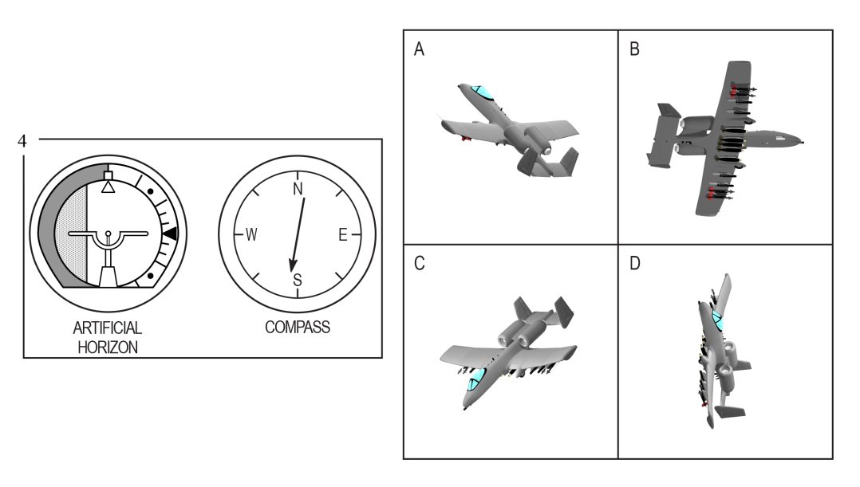

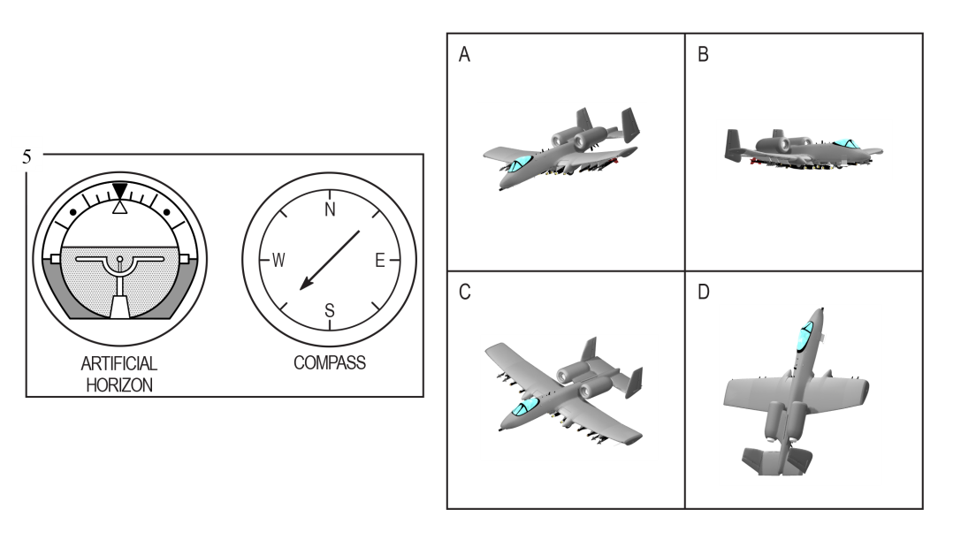

PART B.4 - Block Counting

DIRECTIONS: This part of the test measures your ability to “see into” a 3-dimensional pile of blocks. Given a certain numbered block, your task is to determine how many other blocks the numbered block touches. Blocks are considered touching only if all or part of their faces touch. Blocks that only touch corners do not count. All of the blocks in each pile are the same size and shape. Look at sample questions 1 through 5 below. DO NOT MARK YOUR ANSWER SHEET FOR SAMPLE QUESTIONS.
KEY
Block | A | B | C | D | E
S1 | 1 | 2 | 3 | 4 | 5
S2 | 3 | 4 | 5 | 6 | 7
S3 | 5 | 6 | 7 | 8 | 9
S4 | 2 | 3 | 4 | 5 | 6
S5 | 2 | 3 | 4 | 5 | 6

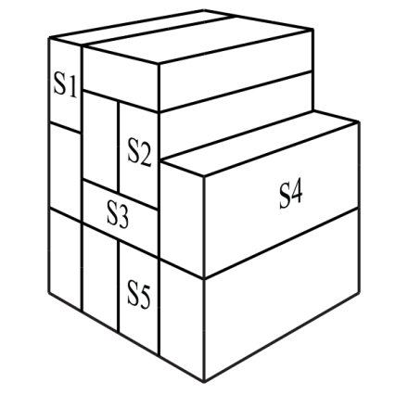

Block S1 touches the faces of the two blocks on the right and one block supporting it. Therefore, the total number of blocks touched by S1 is three. For sample question S1, choice C is the correct answer.

Block S2 touches the faces of blocks S3 and S4 and it rests against the adjacent blocks to its left and on top of it. Because block S2 touches four other block faces, the correct answer for sample question S2 is B.

Now look at sample question S3. S3 touches the faces of the two blocks above it, the two blocks below it, and the blocks directly to the right and left of it. It does not touch the faces of the two blocks diagonally below it to the right or left. These blocks only touch the corners of S3 and do not count. Therefore, S3 touches six blocks, making choice B the correct answer.

Now count the blocks touching blocks S4 and S5. For S4, the correct answer is three, so for sample question S4 choice B is the correct answer. S4 touches blocks S2, S3, and the block below it; it does not touch block S5. For S5, the correct answer is also 3, choice B. S5 touches the blocks to the left and right of it and S3 above it. Once again, block S5 does not touch block S4.

KEY
Block | A | B | C | D | E
1 | 2 | 3 | 4 | 5 | 6
2 | 5 | 6 | 7 | 8 | 9
3 | 1 | 2 | 3 | 4 | 5
4 | 3 | 4 | 5 | 6 | 7
5 | 2 | 3 | 4 | 5 | 6

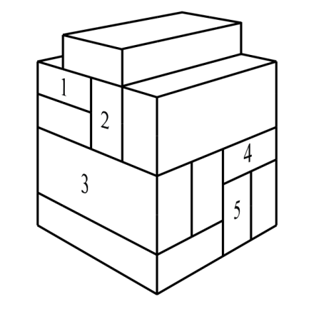

PART B.5 - Aviation Information

DIRECTIONS: This part of the test measures your knowledge of aviation. Each of the questions or incomplete statements is followed by five choices. You are to decide which one of the choices best answers the question or completes the statement.

- The rearward retarding force of airplane drag is opposed by
1-A weight.
  - lift.
  - thrust.
1-D tension.
1-E compression.

- The cowling is located
2-A on the landing gear.
2-B around the engine.
2-C close to the tail.
  - on the wing.
  - inside the fuselage.

- Airport taxiways are identified at night by omnidirectional edge lights. What color are the lights?
  - white
  - amber
  - alternate red and green
  - green
3-E blue

- If the aircraft ammeter is indicating a minus value, this means the
4-A generator or alternator output is inadequate.
4-B electrical system is functioning normally.
4-C battery should be turned off.
4-D battery is adequately charged.
4-E battery requires water.

- The angle formed by the chord of an airfoil and the direction of the relative wind is called the
5-A angle of incidence.
5-B angle of attack.
5-C stall angle of the wing.
5-D pitch angle.
5-E critical angle of attack.

Table 3. ANSWERS TO SAMPLE QUESTIONS

Verbal Analogies Self-Description Inventory
1. | B |  | Note. There are no right or wrong answers for these items.
2. | E
3. | A
4. | C
5. | C
Arithmetic Reasoning Physical Science
1. | A | 1. | E
2. | E | 2. | A
3. | B | 3. | C
4. | D | 4. | C
5. | A | 5. | C
Word Knowledge Table Reading
1. | C | 1. | D
2. | D | 2. | B
3. | A | 3. | A
4. | C | 4. | E
5. | A | 5. | C
Math Knowledge Instrument Comprehension
1. | C | 1. | A
2. | B | 2. | A
3. | D | 3. | D
4. | B | 4. | D
5. | E | 5. | A
Reading Comprehension Block Counting
1. | A | 1. | B
2. | C | 2. | C
3. | E | 3. | E
4. | D | 4. | D
5. | C | 5. | C
Situational Judgment Test Aviation Information
1. | C or D (Most Effective) |  | 1. | C
2. | A (Least Effective) |  | 2. | B
3. | B (Most Effective) |  | 3. | E
4. | E (Least Effective) |  | 4. | A
 |  |  | 5. | B
.

